Online Contest Playbook

Introduction
For the 2020/2021 Toastmasters contest cycle, due to current pandemic, all levels of contests (club, area, division, district and beyond) will be held online. While the bulk of how to run a contest in the conventional way still applies, there are special provisions needed for online contests. This is an attempt to provide a step-by-step guide on how to run these contests and are guidelines only. You may need to adopt for your specific situation.

Before the Contest
- Download Contest rule book and ensure the contest conform to the rules
(https://www.toastmasters.org/-/media/df5b90486396457dade944becca89cf0.ashx)
- Determine contests to run (e.g. International, Table Topics, Evaluation)
- Set contest date(s)
- Assemble officials:
  - Contest Chair (may be you, may be different people for each contest)
  - Chief Judge
  - Test speaker (evaluation only)
  - Timer 1 (No visual timing cues needed for audience)
  - Timer 2
  - Counter 1
  - Counter 2
  - Sergeant-at-Arms/Zoom breakout room master
  - Zoom master (spotlight speakers, breakout room assistant)
  - Judges (check TI rule book for minimum number & requirement depending on contest level)
- Obtain online (Zoom) link (you must be able to host/co-host) (NOTE: since our District standard is Zoom, the specific details will be for Zoom. For other online platforms, see other platform section on variations).
- Confirm contestants
- Prepare/order certificates/trophies
- Download contest form package for contests from Toastmasters.org
  - Certificates
  - Contestant profile
  - Contestant eligibility
  - Judging forms
  - Tie Breaking Judge form
  - Judges Eligibility
  - Timer form
  - Counter form
- Distribute forms:
  - Contestant profile (1189) to contestants
  - Eligibility (1138) to contestants
- Ensure everyone has proper link information

During the Contest
- All officials sign on at least 30 min before contest official start
  - Chair, Chief Judge, Judges, Timers, Counters, Zoom-master/Sergeant-at-Arms (SAA), Test Speaker
- Make Chair, SAA and Zoom master host/co-host to access security & breakout room features
- Ensure all officials rename themselves with their title.
- Where possible, judges should remain anonymous (rename as “Judge” or “Judge #” and videos off/no pictures)
- Ensure SAA/Zoom master has list of names for officials and contestants (to assign to breakout room).
- Update security:
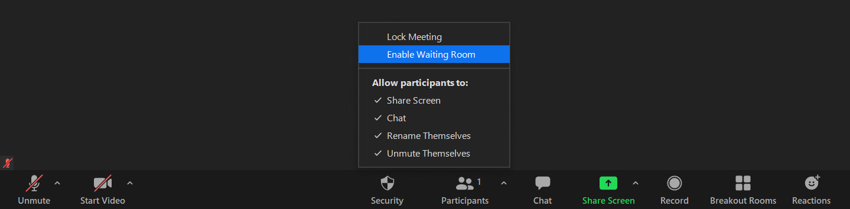
  - Enable Waiting Room (SAA and/or zoom master responsible to allow entry)
  - Disable “Share Screen”
- Create breakout room:
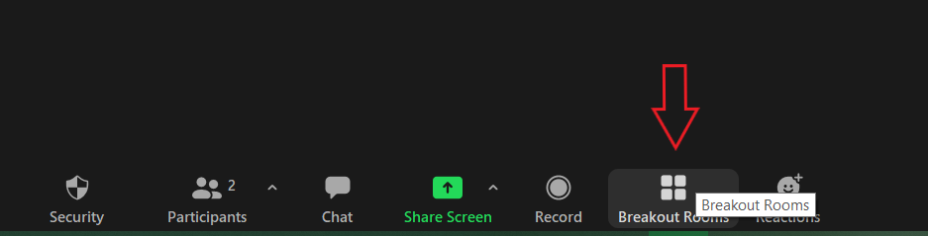

- Select option to “Assign manually”.
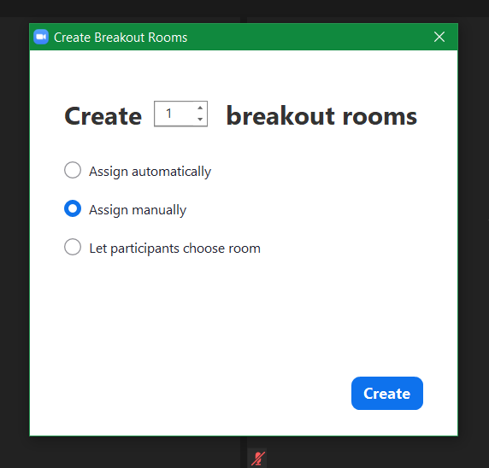
- Assign chief judge and all judges to break out room for judges briefing. (Assign and then “open all rooms”)
JUDGES BRIEFING (with timers, counters) can be done at another time if more convenient. Then the contest can start at the day/time specified)
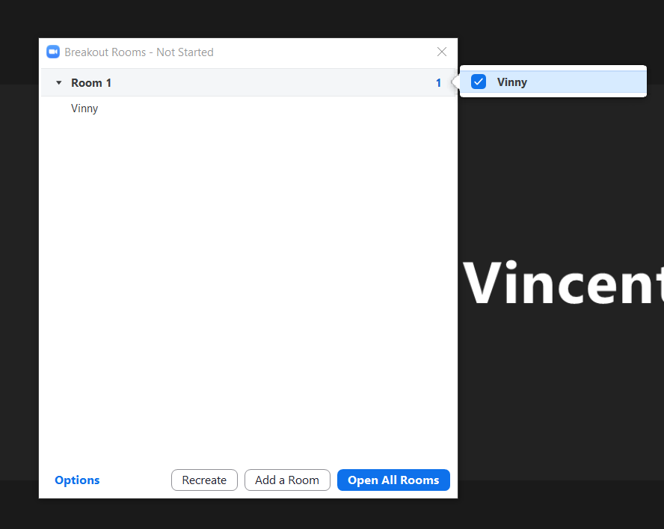

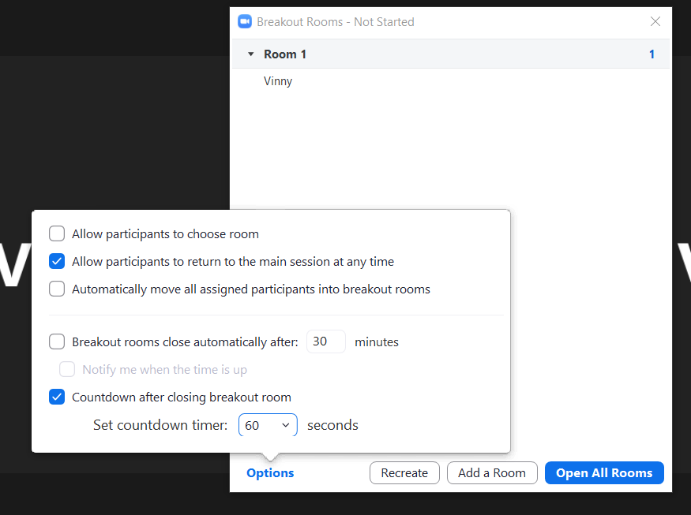
- Chief judge briefs judges
  - How to fill out judges form
  - How to submit judges form (only placement required)
- Chief judge briefs timers
  - Clarify when to start timing
  - Clarify who runs the “light”
  - Submit independent “timer sheet” to chief judge
- Chief judge briefs counters
- Chair briefs zoom masters & SAA
  - SAA to stay in break out (for Table topics & evaluation contest until last contestant)
- (Evaluation contest) Chair brief test speaker separately on timer
- Allow contestants only in for briefing
- Breakout room for Chair & contestants briefing if required
  - Ensure all contestants can see and understand the timing (work with timer)
  - Ensure all speaker mic working as expected
- Open meeting for general admission (5 min before contest start)
- For TT & Evaluation: SAA to create break out room for contestants. Pre-assign who will be in the room, but do NOT select “Open All Rooms”. Just click on the “x” on the top right when assignment is complete.

- SAA/ Zoom master: Mute all participants
- SAA/ Zoom master: Disable chat
- SAA/ Zoom master: Lock meeting (no re-entry except between speakers or until contest completes)
- SAA/ Zoom master: start recording
- Contest Chair: “Welcome to our Toastmasters (Club/Area/Division) (Table Topics/Evaluation/International) speech contest”
- Contest Chair: “In the interest of fairness, during the contest, please remain muted and your cameras off. Only the contest chair, the timer and the contestant speaking shall have their camera remain on.”
- Contest Chair: “The purpose of the _______ contest is ______________.”
- Contest Chair: Explain specific contest procedure
- Contest Chair: “Chief Judge, has all the judges been briefed?”
- Chief Judge: “Yes, Mr/Madame Contest Chair”
- Contest Chair: “Thank you. The contestant speaking order has been drawn at random and for this contest, the speaking order will be: [announce speaking order twice]”
- Contest Chair: “Let the contest begins!”

International Speech Contest
- Contest Chair: “First speaker: [name]. Please ensure you have pinned and can see the timer.”
- Contestant: “Yes, the timer is pinned.” (also echo to validate mike)
- Contest Chair: “Our X speaker: [name] [title] [title] [name]
- Contestant complete speech
- Contest Chair: “We will have 1 minute of silence for the judges” (mute all)
- Contest Chair: can message next speaker to enable video and be ready
- Repeat for each contestant until complete
- Contest Chair: “We will have 2 minute of silence or until all judges to completed and submitted their ballot” (mute all)
- Chief Judge: “We have collected all the ballots”
- SAA/Zoom Master: send chief judge & ballot counters to breakout room
- SAA/Zoom Master: allow users unmute
- Contest Chair: “Please enable your video and unmute to give our contestants a hearty applause!”
- Contest Chair: interview contestants

TT Contest
- Contest Chair: “SAA, please take all contestants except the first speaker to the breakout room”
- Ensure all contestants in breakout room. Communicate with SAA in breakout via broadcast message and/or text.
- Contest Chair: “First speaker: [name]. Please ensure you have pinned and can see the timer.”
- Contestant: “Yes, the timer is pinned.” (also echo to validate mike)
- Contest Chair: “Our X speaker: [name] [topic] [topic] [name] (example: “John Doe; In your opinion, what is the best season? In your opinion, what is the best season? John Doe”
- Contestant complete speech
- Contest Chair: “We will have 1 minute of silence for the judges” (mute all)
- Timer signal 1 minute
- Contest Chair: signal SAA in breakout to send in next speaker.
- Repeat for each contestant until complete
- Contest Chair: “We will have 2 minute of silence or until all judges to completed and submitted their ballot” (mute all)
- Chief Judge: “We have collected all the ballots”
- SAA/Zoom Master: send chief judge & ballot counters to breakout room
- SAA/Zoom Master: allow users unmute
- Contest Chair: “Please enable your video and unmute to give our contestants a hearty applause!”
- Contest Chair: interview contestants
Evaluation Contest
- Contest Chair: “Our evaluation contest speaker today is: [Name] [Title] [Title] [Name]”
- Test speaker do speech (5-7min)
- Contest Chair: “SAA, please take all contestants to the breakout room.” Ensure all contestant moved to breakout
- SAA (in breakout): Ensure all speakers stop note taking at 5 minute mark (Main room timer/chair to send message to SAA).
- Contest Chair: Ask timer to start timing for 5 minutes
- Contest Chair: Interview test speaker / announcements
- Timer: signal 5 minutes up
- Zoom master/Contest Chair: signal SAA to send next contestant from breakout
- Contest Chair: “speaker: [name]. Please ensure you have pinned and can see the timer.”
- Contestant: “Yes, the timer is pinned.” (also echo to validate mike)
- Contest Chair: “Our X contestant: [name] [name]”
- Contestant completes evaluation
- Contest Chair: “We will have 1 minute of silence for the judges” (mute all)
- Timer signal 1 minute
- Zoom master/Contest Chair: signal SAA in breakout to send in next speaker.
- Repeat for each contestant until complete
- Contest Chair: “We will have 2 minute of silence or until all judges to completed and submitted their ballot” (mute all)
- Chief Judge: “We have collected all the ballots”
- SAA/Zoom Master: send chief judge & ballot counters to breakout room
- SAA/Zoom Master: allow users unmute
- Contest Chair: “Please enable your video and unmute to give our contestants a hearty applause!”
- Contest Chair: interview contestants

- Chief Judge: email results to contest chair
- Contest Chair: Thank you all officials
- Contest Chair: “Chief Judge, Do we have the results”
- Chief Judge: “Yes we do”
- Contest Chair: Announce results
- SAA/ Zoom master: stop recording

Other Online Platform
While Zoom is the District standard online platform, we also recognize different clubs may use other similar platforms. We will attempt to detail some variations and alternatives here.

Microsoft Team
Team offers effectively similar functionalities as Zoom.
[More detail to be included…]

Google Meet
Google meet does not provide breakout rooms. Instead, separate meeting may be set up and user need to exit and join different meet links.

Contest Worksheet
Role | International Speech | Evaluation | Table Topics
Contest Chair
Contestant Interviewer (optional)
Chief Judge
Timer 1
Timer 2
Counter 1
Counter 2
Test Speaker | n/a |  | n/a
Sergeant-at-arms/Breakout room
Zoom master (spotlight)
Judge #1
Judge #2
Judge #3
Judge #4
Judge #5
Judge #6
Judge #7
Judge #8

Additional Resources
- Official Rule Book: https://www.toastmasters.org/-/media/df5b90486396457dade944becca89cf0.ashx
- https://www.toastmasters.org/leadership-central/speech-contests/speech-contest-tutorials

